NST21022 - Practical for Network Switching and Routing
Department of Information and Communication Technology
Faculty of Technology
Lab sheet :15
Reg. Number: SEU/IS/20/ICT/084
Academic Year :2020/2021
Practical No :15

Title: Configure DHCPv6
Aim:
● Getting familiar with DHCPv6

Task:
● Configure a Router as a DHCPv6 server
● Configure DHCPv6 relay
● Verify DHCPv6 connectivity

Activities
Use “NST21022 Lab sheet 15.pka” file
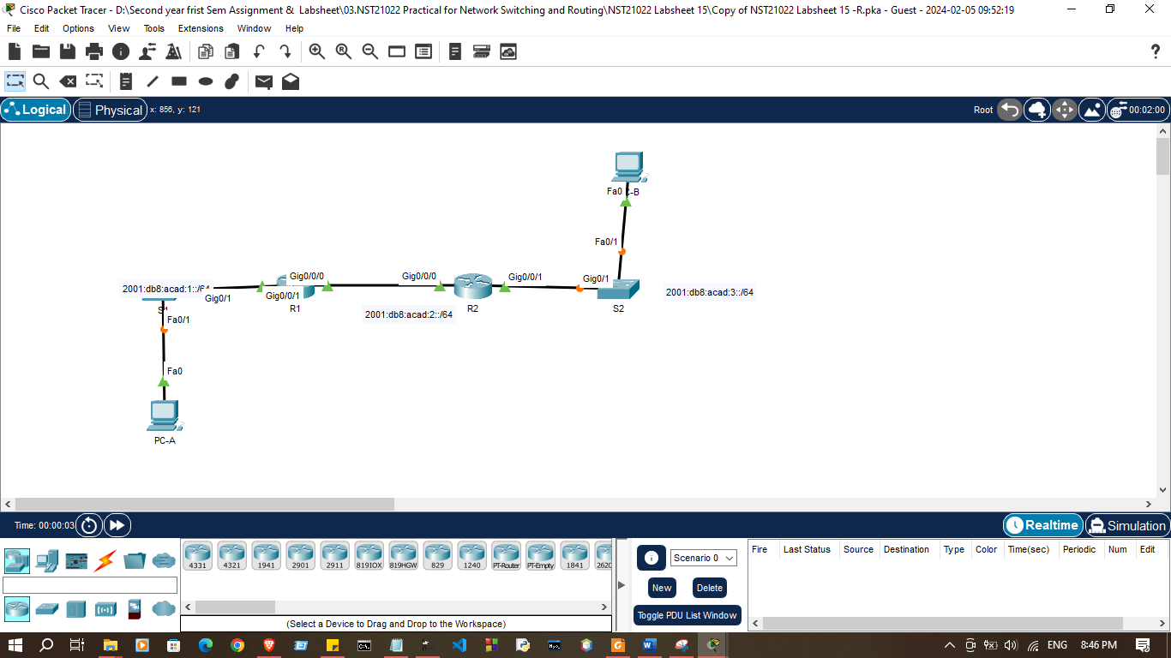

Addressing Table

Device | Interface | IPv6 Address / Prefix
R1 | G0/0/0 | 2001:DB8:ACAD:2::1/64
R1 | G0/0/0 | FE80::1
R1 | G0/0/1 | 2001:DB8:ACAD:1::1/64
R1 | G0/0/1 | FE80::2
R2 | G0/0/0 | 2001:DB8:ACAD:2::2/64
R2 | G0/0/0 | FE80::3
R2 | G0/0/1 | 2001:DB8:ACAD:3::1
R2 | G0/0/1 | FE80::4
PC-A | NIC | DHCP
PC-B | NIC | DHCP
DNS Server | NIC | 2001:db8:acad::254

Exercise 01: Configure a Router as a DHCPv4 server
- Configure IP addresses on each device’s according to addressing table.(Except DNS-Server)

R1#enable
R1#configure terminal
Enter configuration commands, one per line. End with CNTL/Z.
R1(config)#hostname R1
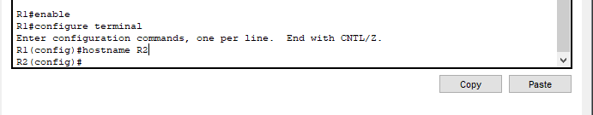
R1(config)#

R2#enable
R2#configure terminal
Enter configuration commands, one per line. End with CNTL/Z.
R2(config)#
R2(config)#hostname R2
R2(config)#
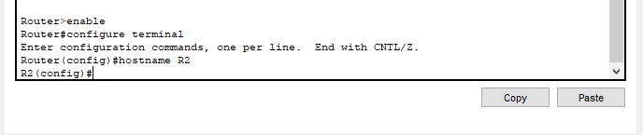

- Enable IPv6 routing in both routers

R1(config)# ipv6 unicast-routing

R1(config)#ipv6 unicast-routing
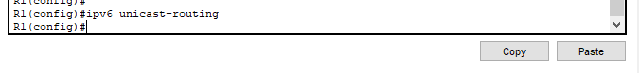
R1(config)#
R2(config)#ipv6 unicast-routing
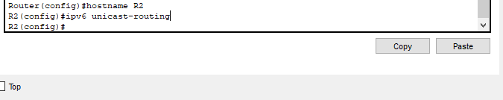
R2(config)#

- Create a stateless DHCP (SLAAC) pool in R1 for R1 LAN named R1-STATELESS (Case Sensitive)

R1(config)# ipv6 dhcp pool R1-STATELESS
R1(config-dhcp)# dns-server 2001:db8:acad::254
R1(config-dhcp)# domain-name stateless.com

R1#configure terminal
Enter configuration commands, one per line. End with CNTL/Z.
R1(config)#
R1(config)#interface g0/0/1
R1(config-if)#ipv6 nd other-config-flag
R1(config-if)#ipv6 dhcp server R1-STATELESS
R1(config-if)#exit
R1(config)#
R1(config)#interface g0/0/0
R1(config-if)#ipv6 dhcp server R2-STATEFUL
R1(config-if)#no shutdown
R1(config-if)#exit
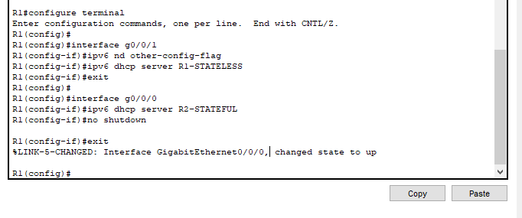

- Configure the G0/0/1 interface on R1 to provide the other config flag to the R1 LAN and assign the DHCP pool.

R1(config)# interface g0/0/1
R1(config-if)# ipv6 nd other-config-flag
R1(config-if)# ipv6 dhcp server R1-STATELESS

R1(config)#ipv6 dhcp pool R1-STATELESS
R1(config-dhcpv6)#dns-server 2001:db8:acad::254
R1(config-dhcpv6)#domain-name stateless.com
R1(config-dhcpv6)#exit
R1(config)#
R1(config)#
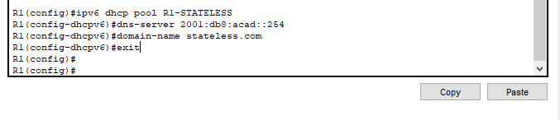

- Enable IPv6 DHCP on PC-A

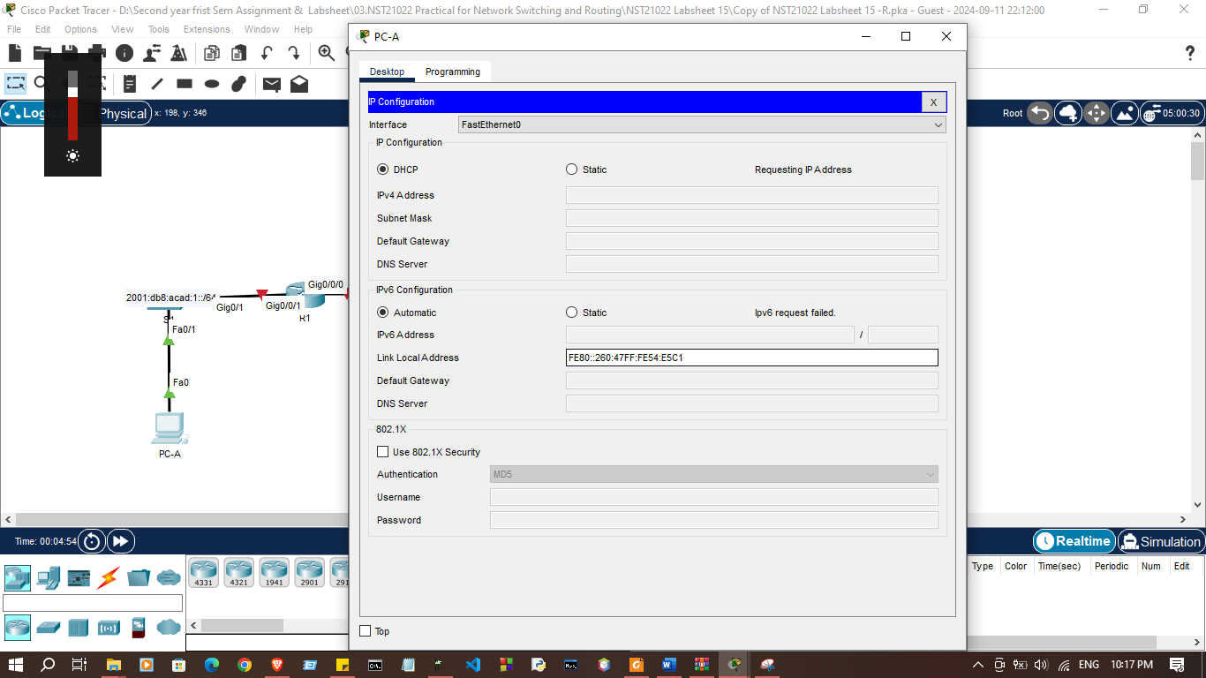

- Examine the output of ipconfig /all and notice the changes.
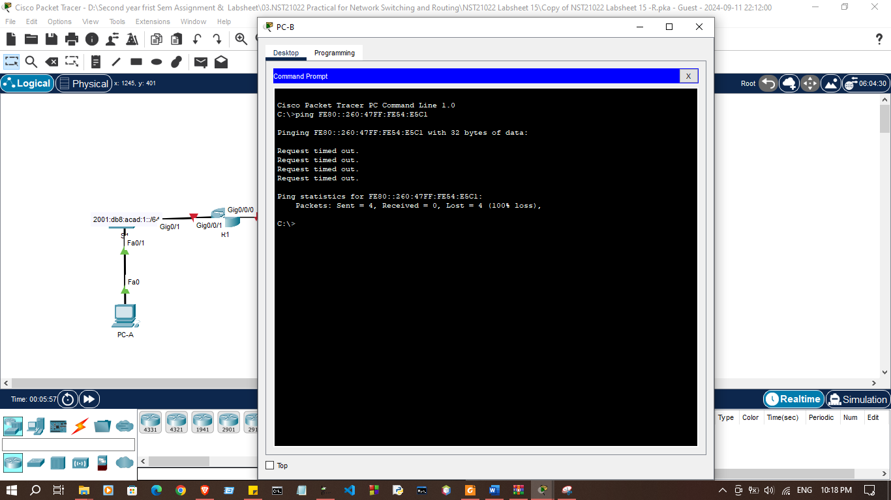

- Create a stateful DHCPv6 pool in R1 for R2 LAN named R2-STATEFUL (Case Sensitive)

R1(config)# ipv6 dhcp pool R2-STATEFUL
R1(config-dhcp)# address prefix 2001:db8:acad:3::/64
R1(config-dhcp)# dns-server 2001:db8:acad::254
R1(config-dhcp)# domain-name stateful.com

R1(config)#ipv6 dhcp pool R1-STATELESS
R1(config-dhcpv6)#dns-server 2001:db8:acad::254
R1(config-dhcpv6)#domain-name stateless.com
R1(config-dhcpv6)#exit
R1(config)#
R1(config)#

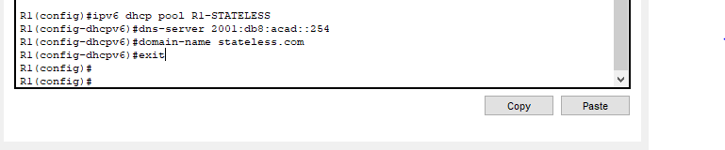

- Assign the DHCPv6 pool you just created to interface g0/0/0 on R1.

R1(config)# interface g0/0/0
R1(config-if)# ipv6 dhcp server R2-STATEFUL

R1(config)#ipv6 dhcp pool R2-STATEFUL
R1(config-dhcpv6)#address prefix 2001:db8:acad:3::/64
R1(config-dhcpv6)#dns-server 2001:db8:acad::254
R1(config-dhcpv6)#domain-name stateful.com
R1(config-dhcpv6)#exit

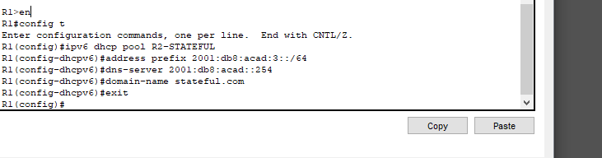
- Configure R2 as an IPv6 dhcp relay agent

R2(config)# interface g0/0/1
R2(config-if)# ipv6 nd managed-config-flag
R2(config-if)# ipv6 dhcp relay destination 2001:db8:acad:2::1 g0/0/0

Note: relay destination command not work for Packet Tracer but work on real router.

R1(config)#interface g0/0/0
R1(config-if)#ipv6 address 2001:db8:acad:2::1/64
R1(config-if)#ipv6 address fe80::1 link-local
R1(config-if)#no shutdown
R1(config-if)#exit
R1(config)#
R1(config)#
R1(config)#interface g0/0/1
R1(config-if)#ipv6 address 2001:db8:acad:1::1/64
R1(config-if)#ipv6 address fe80::2 link-local
R1(config-if)#no shutdown

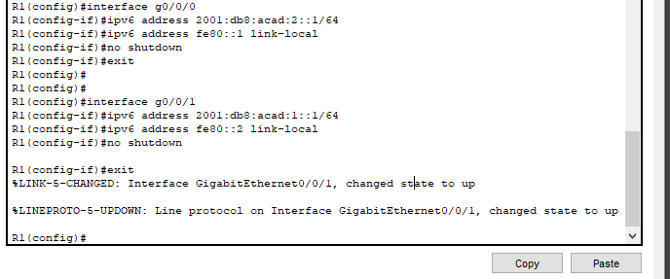
R2(config)#interface g0/0/1
R2(config-if)#ipv6 nd managed-config-flag
R2(config-if)#ipv6 dhcp relay destination 2001:db8:acad:2::1 g0/0/0
^
% Invalid input detected at '^' marker.
R2(config-if)#no shutdown
R2(config-if)#exit
%LINK-5-CHANGED: Interface GigabitEthernet0/0/0, changed state to up

%LINEP
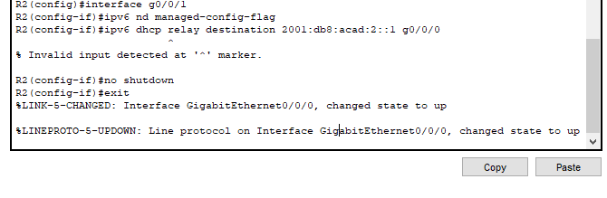

- Verify host IPv6 addresses and connectivity.
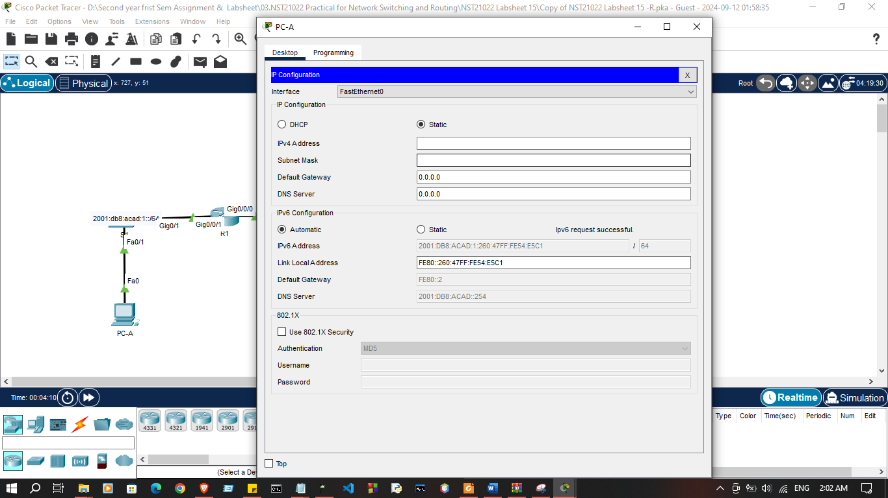

Discussion
- In this lab session, we worked on setting up DHCPv6 to provide dynamic IPv6 address assignment across the network. First, we configured a router to act as a DHCPv6 server, specifying the IPv6 address pool and other network settings to be assigned to clients. Then, we enabled DHCPv6 relay on another router to forward client requests from different subnets to the DHCPv6 server. Finally, we verified the connectivity by checking if the clients received their IPv6 addresses automatically from the server, ensuring that the DHCPv6 server and relay configurations were correctly set up and functional.

